Final Project Reflection

Richard Howell

CS-330

SNHU

4/14/2023

Brian Battersby

*(2D Image for my 3D scene)*

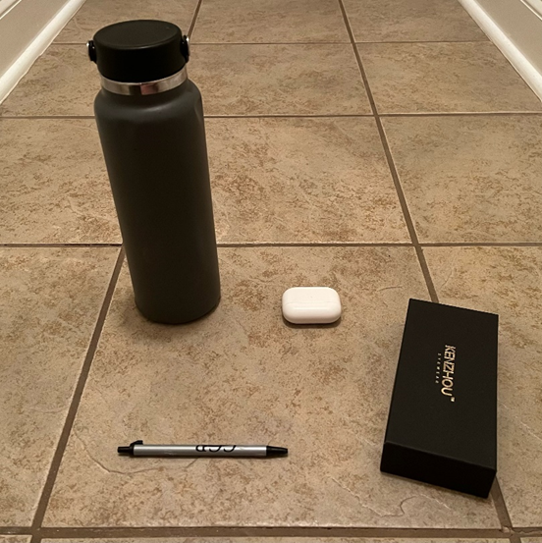

**Justify development choices for your 3D scene.**

The objects I selected for my 3D scene were all items I had readily available at my desk while starting work on my project for this course. I selected these items because I believed they would be relatively simple to work with within the OpenGL library while still meeting the overall requirements for the course. The hydro flask was able to be recreated using two cylinders each textured in a way that best replicated the original picture. The earbuds case and blue light glasses case were able to be recreated using cubes with different scales to recreate the different sizes of the objects. The earbuds case and the blue light glasses case are both rectangular with appropriate textures applied to both shapes. The most complicated object to recreate was the pen. This required me to develop two different cylinders, one for the main body of the pen as well as one for the clicking mechanism. The final shape that was required to recreate the pen was a cone that would represent the type of the pen. I applied textures to each of these objects as well to recreate the scene as closely as possible.

These shapes were all created using a mesh program provided by Professor Brian Battersby. I was able to call the shapes in the source.ccp file from a mesh file that had the meshes for each shape already created. After this I was able to rotate and adjust the scale and positioning of each shape to match as closely to the original scene as possible. This provided the required functionality while maintaining the required modularity and readability of the source file.

**Explain how a user can navigate your 3D scene.**

I was able to set up the virtual camera to be moved around the scene using the W,A,S,D,Q, and E keys while using the mouse to point the camera in the direction that user requires. The scroll wheel was also used to adjust the camera movement speed. Scrolling forward slows the camera movement and scrolling backward speeds the camera movement up. I was also able to provide and create a perspective and orthographic display of the scene by using the O and P keys (O for orthographic and P for perspective). The user can switch between these perspectives by simply pressing these keys at any time. This functionality of moving the camera and switching perspectives was provided by using the UProcessInput, UMousePositionCallback, UMouseScrollCallback, UMouseButtonCallback, and a camera.h file provided by OpenGL in the learning materials. Using all of this together gives the user control of moving around the scene at will in a fluid manner.

**Explain the custom functions in your program that you are using to make your code more modular and organized.**

This was my first experience using OpenGL and most, if not all, of the custom functions that I have used in my code were provided by either OpenGL or Professor Brian Battersby. One of the most important of these custom functions is the Mesh files that were provided by Professor Battersby. This allowed my to call certain meshes at any time to create a shape and adjust the size and scale as necessary and provides and extreme amount of reusability. If a new shape needs to be added to the scene it is as simple as calling the mesh and adjusting the size, scale, and position. The camera file provided by OpenGL also provides a large amount of reusability as well. I can simply link the file in the VCC directories and then set up the movement using the keyboard and I will be able to create movement in any 3D scene that utilizes OpenGL. Between these two functions the reusability of my code is extremely high and would only require slight modifications to change the scene to something completely different. Overall this has been a very good learning experience for me and I look forward to learning more about OpenGL in the future.